Chapter 7, Solution 56.

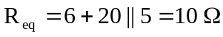, 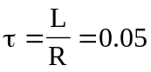
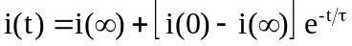

i(0) is found by applying nodal analysis to the following circuit.
2 A
20 
5 
6 
i
v_{x}
12 
20 V

+
−
+
v
−
0.5 H
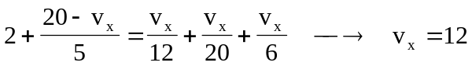
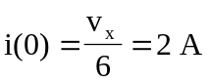

Since 
